Test Case: tc002_SPX_Dev5_Crear_Requisicion_Spot_Tipo_Cobro_Project
Step 1 - Enter username and password and click to button Enter: Credentials Entered
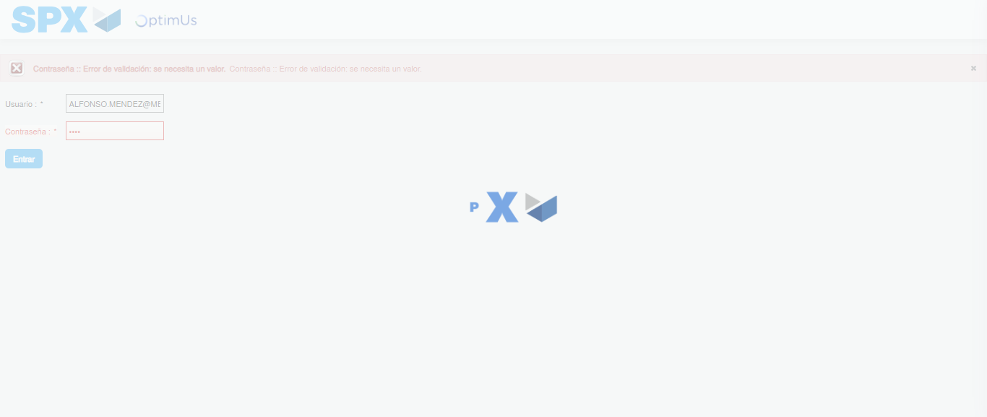Image file-name: QC_Testing-tc002_SPX_Dev5_Crear_Requisicion_Spot_Tipo_Cobro_Project-1783378037502

Step 2 - Select to UEN and Access to Spot Buy Requisitions : UEN Correctly selected and Correct access
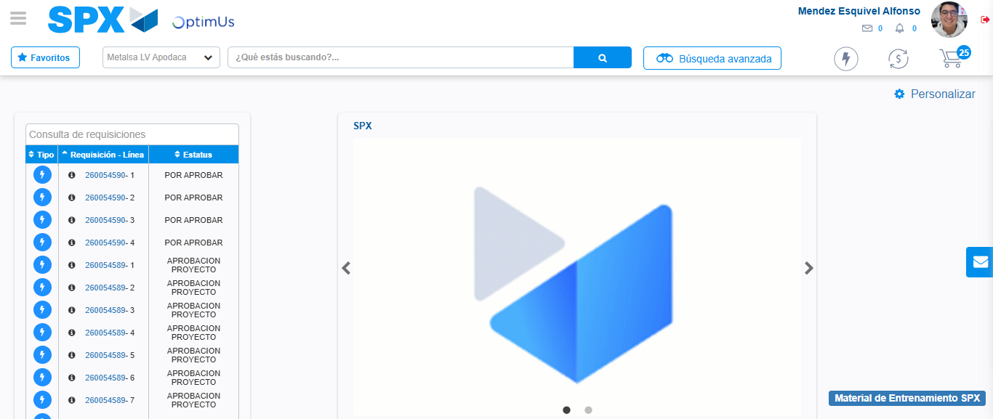Image file-name: QC_Testing-tc002_SPX_Dev5_Crear_Requisicion_Spot_Tipo_Cobro_Project-1783378062589

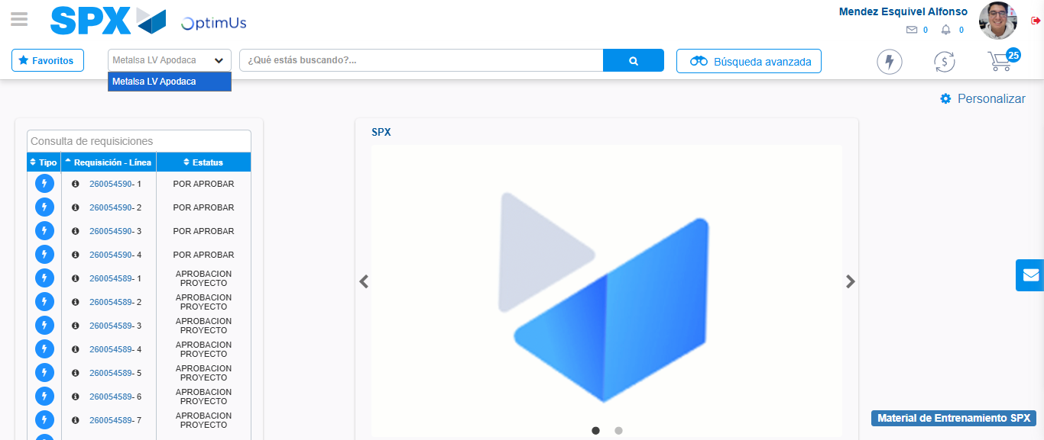Image file-name: QC_Testing-tc002_SPX_Dev5_Crear_Requisicion_Spot_Tipo_Cobro_Project-1783378065065

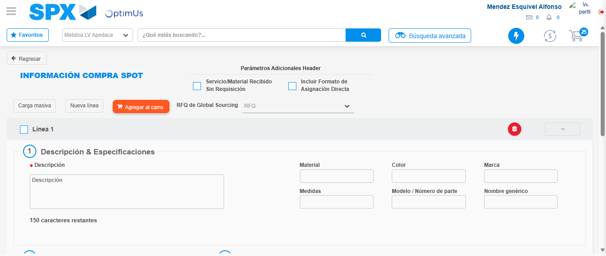Image file-name: QC_Testing-tc002_SPX_Dev5_Crear_Requisicion_Spot_Tipo_Cobro_Project-1783378084245

Step 3 - Data Capture Spot Buy Requisition: Data captured correctly
Image file-name: QC_Testing-tc002_SPX_Dev5_Crear_Requisicion_Spot_Tipo_Cobro_Project-1783378084475

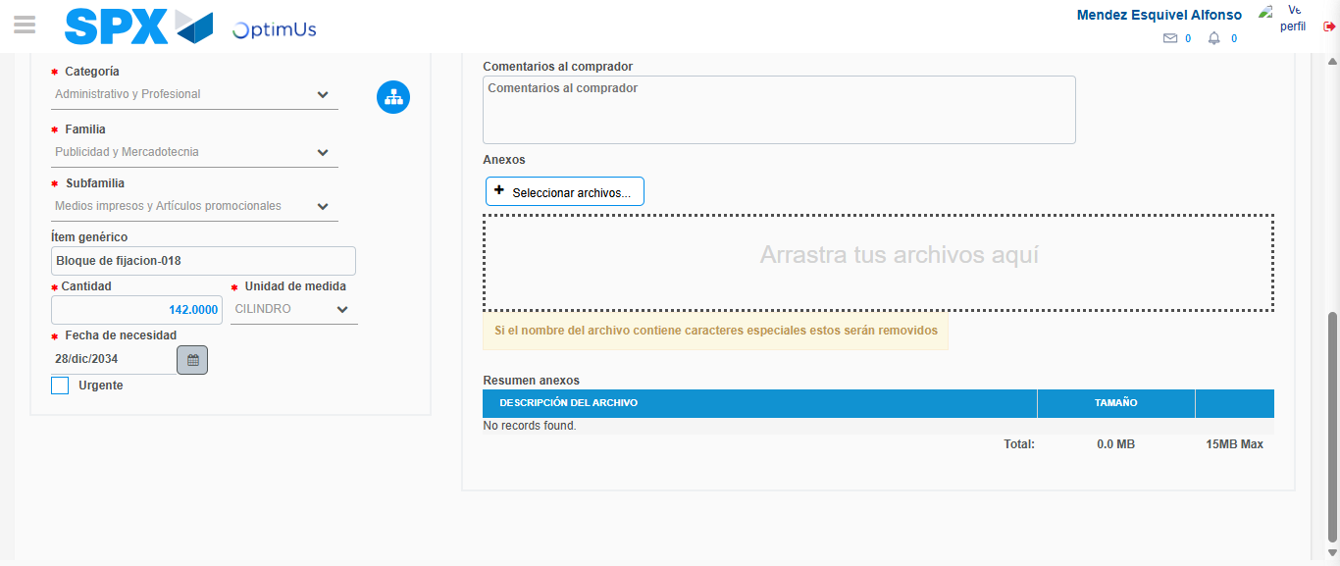Image file-name: QC_Testing-tc002_SPX_Dev5_Crear_Requisicion_Spot_Tipo_Cobro_Project-1783378094306

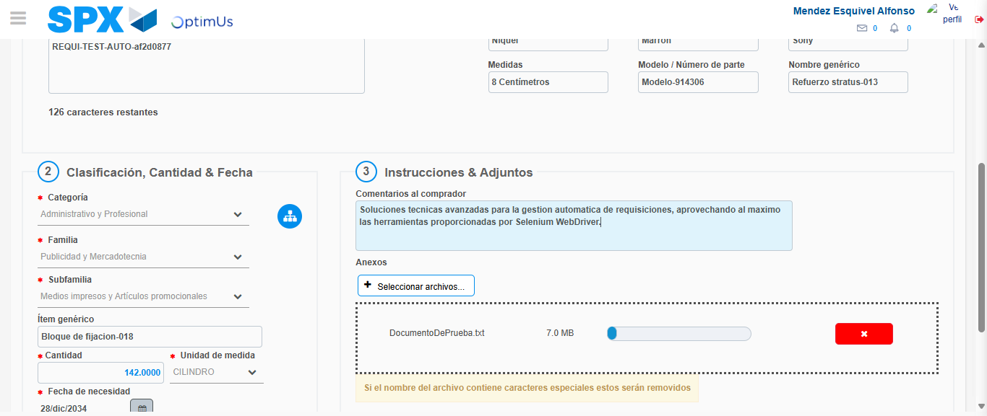Image file-name: QC_Testing-tc002_SPX_Dev5_Crear_Requisicion_Spot_Tipo_Cobro_Project-1783378095018

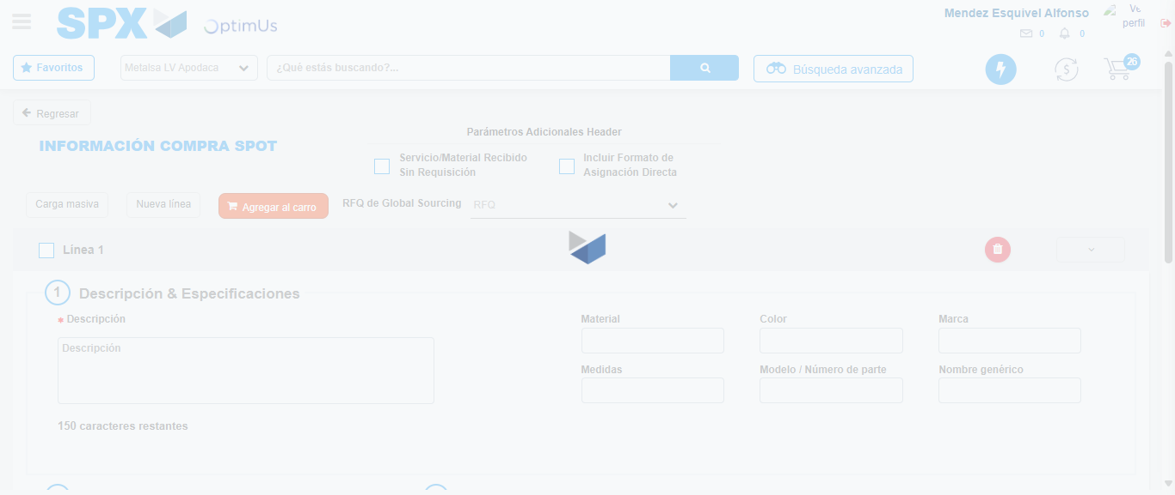Image file-name: QC_Testing-tc002_SPX_Dev5_Crear_Requisicion_Spot_Tipo_Cobro_Project-1783378100854

Step 7 - Return to Main Page SPX : Return to Main Page SPX
Image file-name: QC_Testing-tc002_SPX_Dev5_Crear_Requisicion_Spot_Tipo_Cobro_Project-1783378062589

Image file-name: QC_Testing-tc002_SPX_Dev5_Crear_Requisicion_Spot_Tipo_Cobro_Project-1783378065065

Image file-name: QC_Testing-tc002_SPX_Dev5_Crear_Requisicion_Spot_Tipo_Cobro_Project-1783378084245

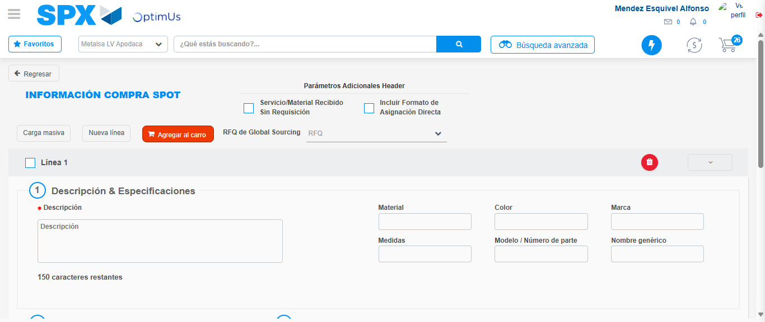Image file-name: QC_Testing-tc002_SPX_Dev5_Crear_Requisicion_Spot_Tipo_Cobro_Project-1783378103067

Image file-name: QC_Testing-tc002_SPX_Dev5_Crear_Requisicion_Spot_Tipo_Cobro_Project-1783378103235

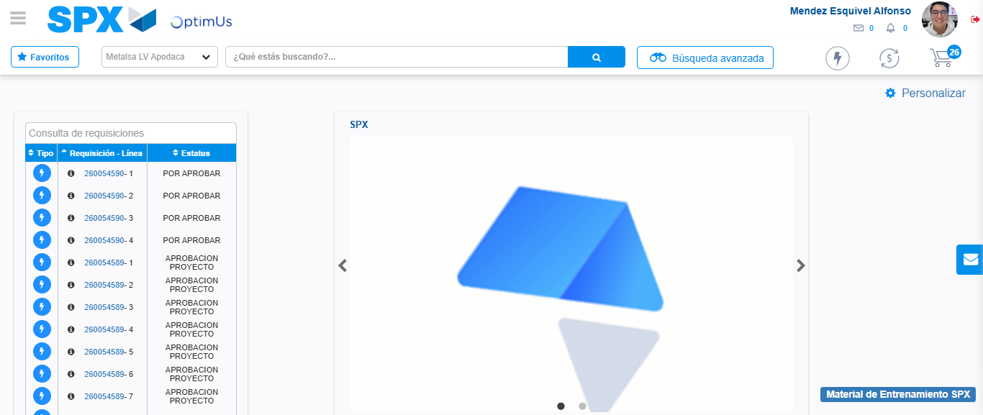Image file-name: QC_Testing-tc002_SPX_Dev5_Crear_Requisicion_Spot_Tipo_Cobro_Project-1783378124281

Step 8 - Log Out : Log Out SPX
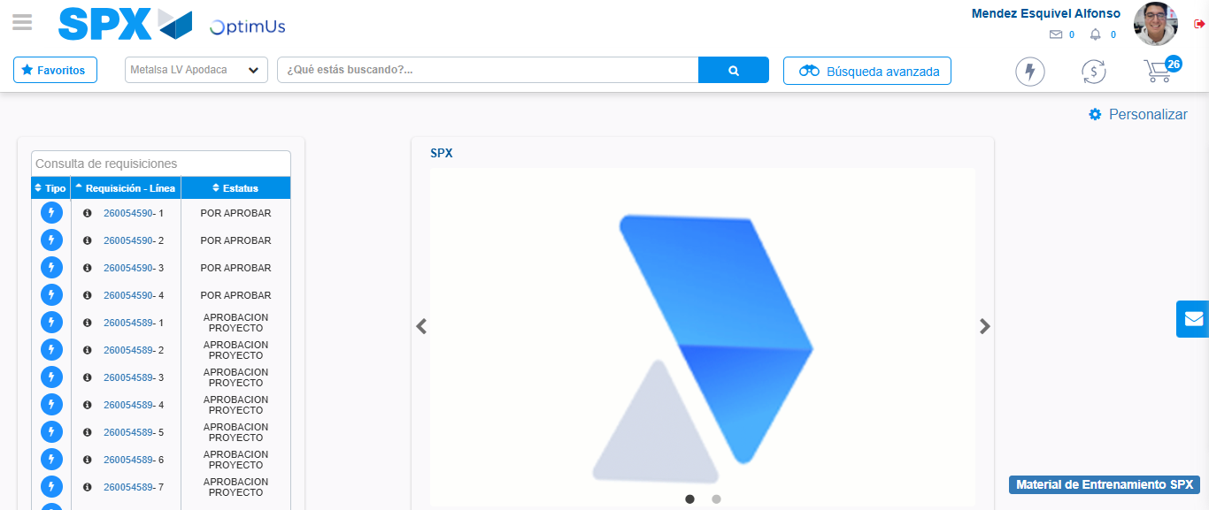Image file-name: QC_Testing-tc002_SPX_Dev5_Crear_Requisicion_Spot_Tipo_Cobro_Project-1783378124563

